**ADDING ANIMATION TO AN APP**

adding animation to an app can greatly enhance its overall appeal and usability by creating a more engaging and interactive experience for users. Animations can serve functional purposes, such as guiding users through transitions, highlighting important elements, or providing feedback during interactions, making the app more intuitive to use. They also add a layer of polish and professionalism, giving the app a dynamic and modern feel. However, it’s important to use animations thoughtfully and sparingly, as excessive or poorly executed animations can lead to slower performance and distract users from the app's main purpose. When done right, animations not only improve the aesthetic quality of an app but also contribute to a seamless and enjoyable user experience.

**USING ANIMATED CONTAINER**

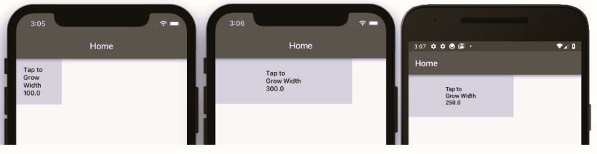

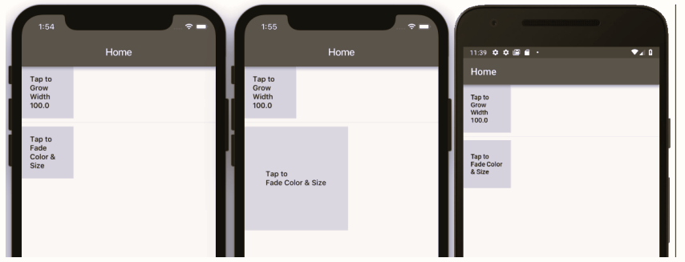

**USING ANIMATEDOPACITY**

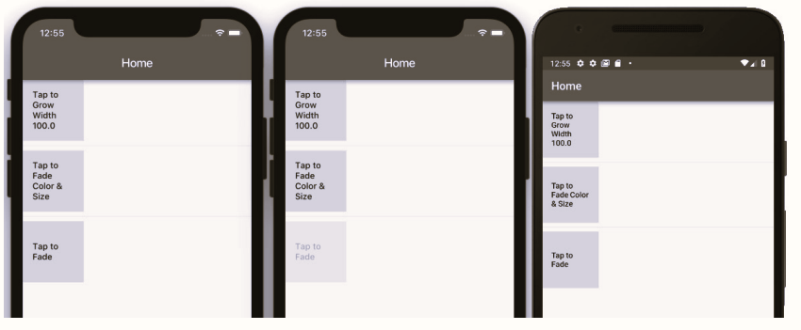

**USING ANIMATIONCONTROLLER**

